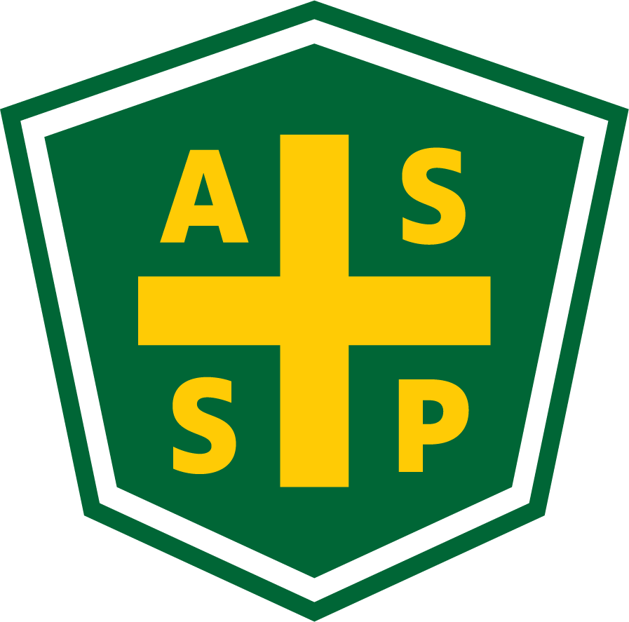

New Mexico Chapter – Albuquerque, New Mexico
Executive Board Committee Meeting Minutes

December 8, 2020

5:00 PM-6:00 PM

Location: Teleconference- (605) 313-4100 Access code: 392237

Attendance:
President – Marc Evans | TC | Quorum Present? | Yes
President Elect – Bill White | TC | Membership- Jessica Bolduc | TC
Vice President – Tim Riley | TC | Foundation- | NP
Treasurer/Delegate – Mario Hildago | TC | Los Alamos Section – Gary Whitney | NP
Secretary – Gary Wright | TC | Pecos Valley Section - | NP
Delegate – Chuck Atwood | TC | Zia Section – Juanita Miller | NP
Delegate – Kelsey Forde | TC | Newsletter Editor – Andrea Heacock-Reyes | NP

AL = At Location TC = Teleconferenced NP = Not Present
Note: All motions should include exact wording and names of those who move and second.

Meeting called to order at 1700 by Marc Evans.
Topic 1 | Meeting Minutes | Marc E.
 | - Read and Approved
Topic 2 | Treasure’s Report | Mario H.
- $32,500.96 Total; No outstanding checks.
  - Checking: $13,977.28
  - Savings: $5,121.02
  - CD: $13,402.66

Topic 3 | Sections | Marc E.
- No Sections called into the Exec Meeting.
- Marc looking to reengage with Los Alamos Section

Topic 4 | Member Appreciation Event (MAE) | Marc E./  Kelsey F.
 | - Kelsey asked if the MAE was announced because it doesn’t seem to have been.  - MAE tentatively scheduled for 12/10  - Kelsey working on redistributing information  - Marc suggested the MAE be moved to 12/17 @ 6:00 PM  - Kelsey to send update to EC | .
Topic 5 | Newsletter | Marc E.

Did the November newsletter get delivered?
- Kelsey was wondering if the messages from the Society were being delivered. The following EC members have NOT been receiving emails from the Society:
  - Mario H., Jessica B., Bill W., Chuck A., and Gary W.
- Marc will check with Mark (Society webmaster) to check on NM member list.

Topic 6 | Jack Bacastow Passing | Chuck A.
- Announce Jack Bacastow passing in January newsletter or next one.
  - Kelsey suggested getting with the LA section for information about him and his contributions to NMASSE and safety.

Topic 7 | Technical Meeting | Bill W.
 | - Bill to contact Cintas for speaker at next meeting

Meeting adjourned at 1802.

Next Executive Committee Meeting: 01/05/2021@ 1700- Teleconference

Minutes respectfully submitted by Gary A. Wright, Chapter Secretary, January 5, 2021.

