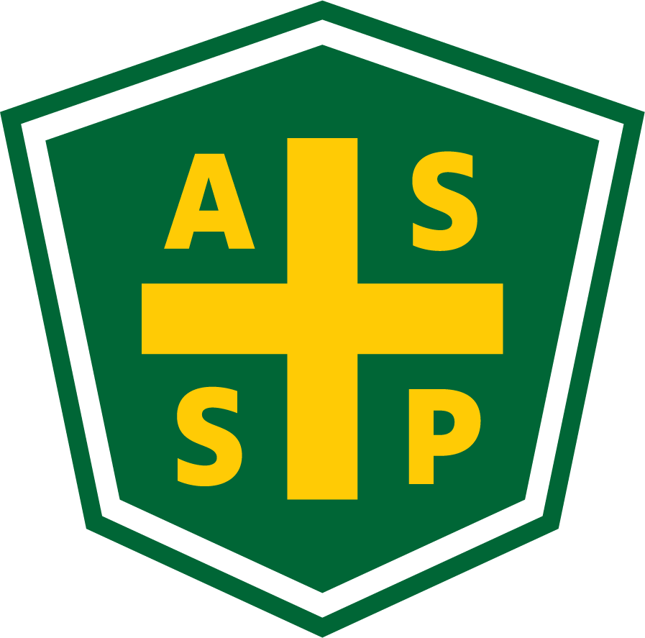

New Mexico Chapter – Albuquerque, New Mexico
Executive Board Committee Meeting Minutes

February 2, 2021

5:00 PM-6:00 PM

Location: Teleconference- (605) 313-4100 Access code: 392237

Attendance:
President – Marc Evans | TC | Quorum Present? | Yes
President Elect – Bill White | TC | Membership- Jessica Bolduc | TC
Vice President – Tim Riley | TC | Foundation- | NP
Treasurer/Delegate – Mario Hildago | TC | Los Alamos Section – Gary Whitney | NP
Secretary – Gary Wright | TC | Pecos Valley Section - | NP
Delegate – Chuck Atwood | NP | Zia Section – Juanita Miller | NP
Delegate – Kelsey Forde | TC | Newsletter Editor – Andrea Heacock-Reyes | TC

AL = At Location TC = Teleconferenced NP = Not Present
Note: All motions should include exact wording and names of those who move and second.

Meeting called to order at 1707 by Marc Evans.
Topic 1 | Meeting Minutes | Marc E.
 | - Read and Approved
Topic 2 | Sections | Marc E.
 | - Gary Whitney asked Marc E. to find another contact for the LA section
Topic 3 | Technical Meeting | Tim R.
 | - January’s meeting went well, and Jay is interested in presenting at the PDC  - February Tech Meeting- Pat Esick from Cintas  - March- Tim to find a Speaker  Kelsey to send ZOOM meeting link | .
Topic 4 | Newsletter | Andrea H-R
- Andrea issued a save the date for the PDC in the Newsletter
- Waiting on one article before publishing
Topic 5 | Spring PDC | Bill W.
- Week of April 12, 2021; 4, ½ days
- DJ Heckes could not make this meeting
  - She needs to know number of attendees, vendors, and sponsors
  - Logos from each Vendor
- Exhibit! Requires 50% payment to begin work and the balance on first day of PDC
  - Kelsey to work with Mario because they only have a credit card
- Use info from 2019 PDC for speaker/vendor numbers to work with Exhibit! plan for 75-90 attendees
- Marc to work on getting speakers from SNL
- Kelsey- ASSP national needs 3-4 weeks to work thru to award the CEUs
- Perhaps reach out to Carol Walker and Bob Dunnington to package the CEU submission (Gary W. contacted Carol W.) to get abstracts/ bios/ author info
- We will send a blast out each week until then to raise awareness and excitement
- Templates are in the file from last year and before
- Bill to ask for sponsors on LinkedIn
- We will offer sponsors/exhibitors to add a link to their online stores
- NMOSHA/BCSP/NMASSP to share a “booth”
- Have NMASSP intro and introduce keynote speakers before the presentations begin
- Kelsey has an idea for keynote speaker from the nuclear world, SNL nuclear Jeff Brewer
- Bill to have meeting with DJ, Bill, Tim, Kelsey and Gary to go over expectations before tech meeting at 1100
- Marc suggests PDC Check-in in 2 weeks 16 or 19 Feb Tuesday 16th at 1700

Topic 6 | Roundtable | Everyone
- Mario reported that the NMASSP received up to $300 in Road Runner Food Bank donations- NMASSP to match that amount to present to RRFB
- Kelsey to pay the deposit with Mario’s agreement

Meeting adjourned at 1758.

Next Executive Committee Meeting: 02/02/2021@ 1700- Teleconference

Minutes respectfully submitted by Gary A. Wright, Chapter Secretary, March 2, 2021.

