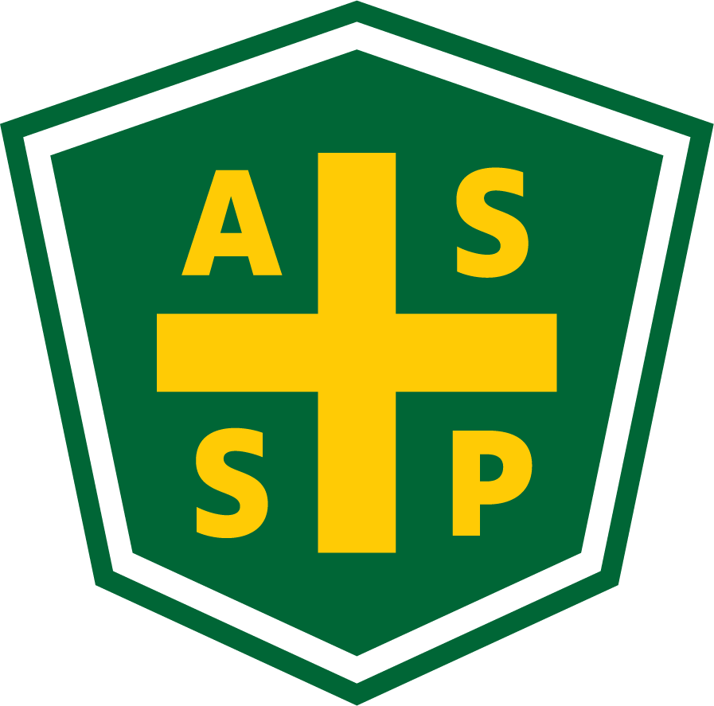

New Mexico Chapter – Albuquerque, New Mexico
Executive Board Committee Meeting Minutes

March 2, 2021

5:00 PM-6:00 PM

Location: Teleconference- (605) 313-4100 Access code: 392237

Attendance:
President – Marc Evans | TC | Quorum Present? | Yes
President Elect – Bill White | TC | Membership- Jessica Bolduc | TC
Vice President – Tim Riley | TC | Foundation- | NP
Treasurer/Delegate – Mario Hildago | TC | Los Alamos Section – Gary Whitney | NP
Secretary – Gary Wright | TC | Pecos Valley Section - | NP
Delegate – Chuck Atwood | TC | Zia Section – Juanita Miller | NP
Delegate – Kelsey Forde | TC | Newsletter Editor – Andrea Heacock-Reyes | TC

AL = At Location TC = Teleconferenced NP = Not Present
Note: All motions should include exact wording and names of those who move and second.

Meeting called to order at 1703 by Marc Evans.
Topic 1 | Meeting Agenda | Marc E.
 | - Read and Approved
Topic 2 | Meeting Minutes | Marc E.
 | - Read and Approved
Topic 3 | Sections | Marc E.
- LA Section- Possible contacts: Bill Reid, Kristen Coggins
- Zia Section- Juanita (on email invite)
- Pecos Section- Kristen (?).

Topic 3 | Technical Meeting | Tim R.
- March- Tim found a Speaker
Kelsey to send ZOOM meeting link
- May- Try for CINTAS again for February SNAFU.
Topic 4 | Newsletter | Andrea H-R
 | - March- President’s Message, Tech Meeting announcement, PDC announcement.
Topic 5 | Spring PDC | Bill W.
- Vendor Status- 5 Vendors verified so far:
  - Ace Consulting
  - Downy Agency
  - Grancor
  - Black Hills
  - OES
- Sponsors
  - Marc to call CloverLeaf for possible sponsorship
  - Bill to call Crane Services and CINTAS
  - Marc to engage SNL/Honeywell/NTESS for sponsorship due to Kelsey’s suggestion
- Keynote Speakers
  - Marc asked Kelsey to engage PK O’Reilly as a possible keynote speaker or presenter
- Speakers- 8
  - Day 1: S. Jaramillo, K. Forde, Jessica (?)
  - Day 2: S. Jaramillo, T. Stirrup, J. Stimmel
  - Day 3: J. English, J. Sanchez, C. Wheaton (possibility)
  - Marc E. suggested M. Bryan, B. Schleyer, L. De Haro
- We need to ask Exhibit! For another week despite the fact that we are late for a deadline
- Mario to send Bill the PayPal links
- Jessica to break down roster for EC to personally call members to invite them to the PDC
- Bill to work with Mark at ASSP to set up links and list sponsors on the NMASSP website.

Topic 6 | Roundtable | Everyone
- Marc suggested we start looking for EC officers
- Kelsey reported Tim Stirrup showing interest in becoming an Officer
- Gary mentioned the Secretary spot will be open
- Bill to send Andrea the LinkedIn account info to Andrea to post in Newsletter
- Mario reported that the NMASSP has $33,342.92 total
  - Exhibit! = $2800
  - Road Runner Food Bank = $790 from matching donations from the membership.

Meeting adjourned at 1807.

Next Executive Committee Meeting: 04/06/2021@ 1700- Teleconference

Minutes respectfully submitted by Gary A. Wright, Chapter Secretary, April 5, 2021.

