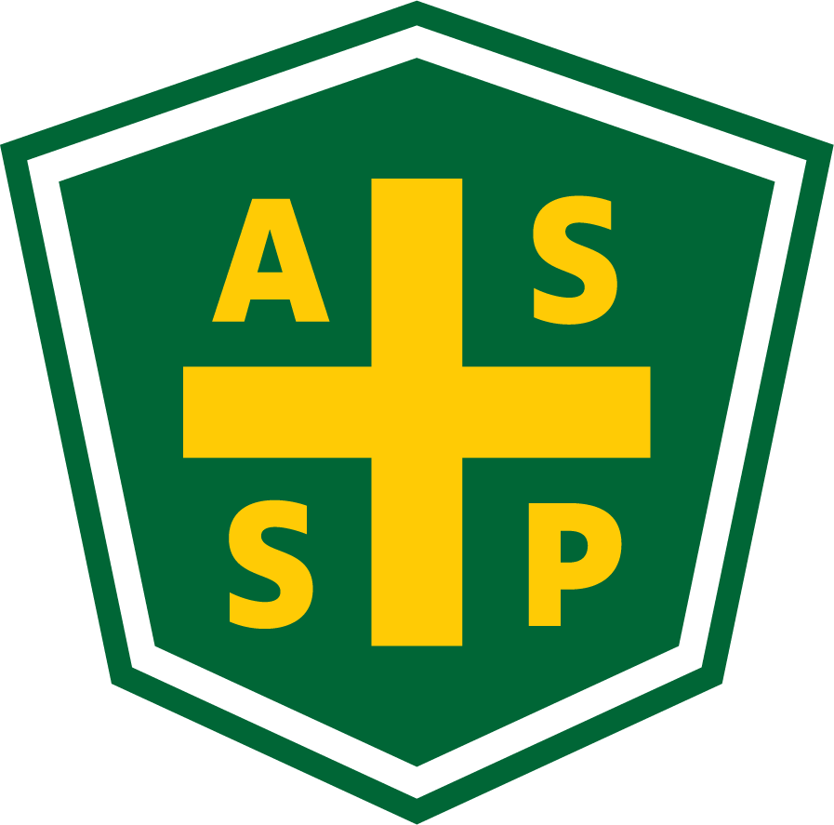

New Mexico Chapter – Albuquerque, New Mexico
Executive Board Committee Meeting Minutes

May 4, 2021

5:00 PM-6:00 PM

Location: Teleconference- (605) 313-4100 Access code: 392237

Attendance:
President – Marc Evans | TC | Quorum Present? | Yes
President Elect – Bill White | TC | Membership- Jessica Bolduc | TC
Vice President – Tim Riley | NP | Foundation- | NP
Treasurer/Delegate – Mario Hildago | TC | Los Alamos Section – Gary Whitney | NP
Secretary – Gary Wright | TC | Pecos Valley Section – Kathy Louer | NP
Delegate – Kelsey Forde | NP | Zia Section – Juanita Miller | NP
Delegate – | NP | Newsletter Editor – Andrea Heacock-Reyes | NP

AL = At Location TC = Teleconferenced NP = Not Present
Note: All motions should include exact wording and names of those who move and second.

Meeting called to order at 1704 by Marc Evans.
Topic 1 | Meeting Agenda | Marc E.
 | - Read and Approved
Topic 2 | March Meeting Minutes | Marc E.
 | - Read and Approved
Topic 3 | Treasurer’s Report | Mario H.
- End of March ~$29,000.00
- Still have receipts to go through
- Received a financial report from LA Section sent a check
  - waiting for Zia Section
- Need Financial Report for the Society at end of May
- Downy needs to send us a check for $500 for being a sponsor

Topic 4 | Technical Meeting | Marc E.
- May Technical Meeting Coordination- Do we have any ideas for May Tech Meeting?
  - Bill motioned we consider skipping a meeting in May and wait for June, Mario seconded- Motion Passed
- Marc and Jessica to meet to get speaker for June Tech meeting

Topic 5 | Succession Planning | Marc E.
- Next Year's Officers
  - Delegates- Marc Evans and Kelsey Forde
  - President- Bill White
  - President Elect- Tim Riley
  - Secretary- OPEN
  - Treasurer- OPEN
  - Membership- Jessica Bolduc to consider one of the open slots
- Potential Future Officers- need one year of being in the ASSP
  - Tim Stirrup- Kelsey F. mentioned would be interested in being an Officer
  - Marc E. considers approaching
    - Leyma De Haro
    - Jessica Costanzo
  - Mario H. to reach out to a friend
  - Bill W. to reach out to Joe Metatuchi, John Garcia, Joe Folk, and Joe Hill to see If interested
  - Jessica B. to reach out to Sherry Fanning
- We need to provide list of names one month for members to consider
- Marc to follow up late next week

Topic 6 | Spring PDC | Bill W.
- What went well? - Presentations looked really well; the Sponsors were happy.
  - Overall, Bill W. is very pleased; happier than expected
  - Jessica B.- The presentations seemed more engaged than she expected especially in the chats
- What were challenges? - Bill estimates attendance being 35-40 and more sponsors than expected
  - Marc wondered if we should do this again- Is there ZOOM fatigue?
  - Mario H., Bill W., and Gary W. prefers in-person meetings over on-line
  - NMASSP didn’t have a booth so we couldn’t engage as a chapter as well
- Tim R. was asked for the number of signups to date
- Post Videos of Presentations on Website? – Marc got verbal permission to post the trainings from many of the speakers
  - Marc to send an email to all presenters to ask permission for us to offer their presentations to NMASSP Members.
  - We should consider grouping the videos like 3 or 5 videos for a certain price or a lump sum fee for access for all the presentations $100 for full access.
  - Members who already paid do not have to pay the $100 to view the videos.
- Mario will check into the numbers to see how much exactly NMASSP
  - $5000 went to Exhib-it! We had 12 sponsors; we made approximately $700 profit

Topic 6 | Newsletter | Marc E.
- Use it to advertise June’s Tech Meeting
- Jess to write Recruit new officers article
- Bill and Gary to write up thoughts on PDC
- Marc to advertise article about Spring PDC for on how to access the videos for a fee and communicate the June Tech meeting and ask Tim to advertise in the SDN and ROC

Topic 7 | Roundtable | Everyone
- April Treasurer’s report Mario to send out within the week
  - NMASSP needs a Treasurer’s audit
- Bill brought up we really need a secretary to get the Chapter report done. Marc said we all will pitch in and get it done!
- Mario suggested we reach out to the SNL ES&H Coordinator managers for new Officers and to pass along NMASSP information
- Marc (and All) thanked Bill for a job well done for the PDC

Meeting adjourned at 1751.

Next Executive Committee Meeting: 05/04/2021@ 1700- Teleconference

Minutes respectfully submitted by Gary A. Wright, Chapter Secretary, June 7, 2021.

