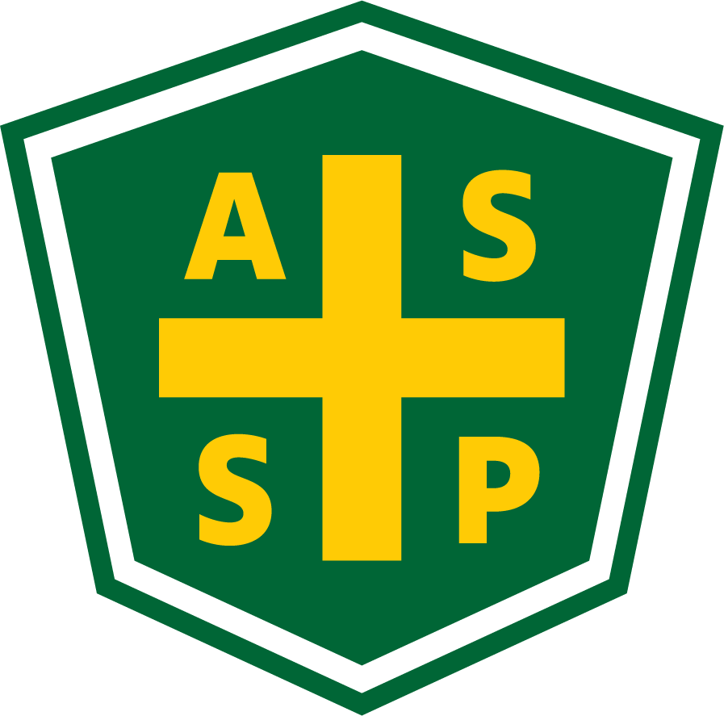
New Mexico Chapter – Albuquerque, New Mexico
Executive Board Committee Meeting Minutes
Tuesday, July 6, 2021
5:00 PM-6:00 PM
Location: GranCor Office - 2121 Menaul Blvd NE Albuq. NM 87107
Zoom Meeting
Call In – (301)715-8592
Meeting ID: 841 9725 2370
Passcode: 859732

Attendance:
President – Bill White | AL | Quorum Present? | Y
President Elect – Tim Riley | TC | Membership | NA
Vice President – Tim Stirrup | AL | Foundation | NA
Treasurer – Gail Mattson | TC | Los Alamos Section | NP
Secretary – Jessica Bolduc | TC | Pecos Valley Section | NP
Delegate – Marc Evans | TC | Zia Section | NP
Delegate – Kelsey Forde | AL | Newsletter Editor - Andrea Heacock-Reyes | TC

AL = At Location TC = Teleconferenced NP = Not Present
Note: All motions should include exact wording and names of those who move and second.

Call to order: 17:01
Topic 1 | Meeting Minutes | Bill White
 | - Read and approved
Topic 2 | Technical Meeting | Bill White
July - Copper Grill - Second Thursday of each month – Craig Spooner (Demand Safety)
Off-schedule - Stick to 2nd Thursday to improve attendance and keep calendars current.
August & September - Tim & Tim identify speakers (Janet Curley to be asked)
October - Kelsey and Tim @ Rio Bravo Brewing
November & December - TBD

Other Information and Conversation
- Zoom information & early info to members to improve attendance
- Long term plan for teleconference options for meetings (Kelsey)
  - Motion put forth to purchase microphone & camera - Bill W.
    - Second - Kelsey F.
  - Kelsey to purchase with NMASSP funds
- Link calendar to LinkedIn account with at least placeholders (date, time, location)
- Santa Fe meetings optional - twice per year? (Gail)
Topic 3 | By-Laws | Kelsey Forde
- Kelsey researching current by-laws - no signatures in most current versions.
- Most recent version will be sent to Exec. Committee - out-going officers copied for awareness and incoming officers will review and red-line.
- Andrea will maintain the draft version.
- Strategic Planning meeting for review - August Exec. Board
- Review during a Technical Meeting with membership
Topic 4 | Dues for Officers | Andrea Heacock-Reyes
- Andrea had dues paid for by NMASSP for her term as newspaper editor.
- Motion put forth to pay Andrea’s dues - Bill W.
  - Second - Kelsey F.
- Further discussion around dues to be paid for NMASSP officers.
Topic 5 | Alliance with State | Bill White

Signed alliance missed due to COVID-19 virtual requirements.
- Reach out to check status and options.
Actions
 | Credit Union for Treasurer transition  - Mario Hidalgo will transition out of the NMASSP Treasurer position and Gail Mattson will transition into the NMASSP Treasurer position (Transfer 7/1/2021) | Bill, Gail, Mario
 | By-laws – Review | All
 | Leadership Training – Complete position specific training before August meeting. | All
Meeting Adjourned: 17:59

Next Executive Committee Meeting: August 3, 2021

Minutes respectfully submitted by Jessica Bolduc, Chapter Secretary, July 6, 2021.

