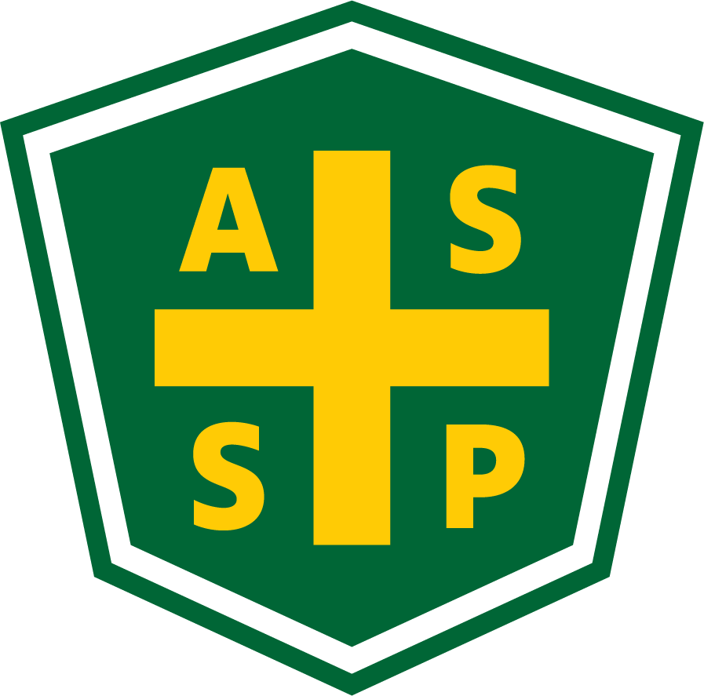
New Mexico Chapter – Albuquerque, New Mexico
Executive Board Committee Meeting Minutes
Tuesday, September 7, 2021
5:00 PM-6:00 PM
Zoom Meeting
Call In – (301)715-8592
Meeting ID: 857 1550 8311
Passcode: 928131

Attendance:
President – Bill White | TC | Quorum Present? | Yes
President Elect – Tim Riley | NP | Membership | NA
Vice President – Tim Stirrup | TC | Foundation | NP
Treasurer – Gail Mattson | TC | Los Alamos Section | NP
Secretary – Jessica Bolduc | TC | Pecos Valley Section | NP
Delegate – Marc Evans | NP | Zia Section | NP
Delegate – Kelsey Forde | TC | Newsletter Editor - Andrea Heacock-Reyes | TC

AL = At Location TC = Teleconferenced NP = Not Present
Note: All motions should include exact wording and names of those who move and second.

Call to order: 17:04

Topic 1 | Agenda | Bill White
 | - Discuss president’s gift $150 amount - Bill moves, Kelsey seconds
Topic 2 | Meeting Minutes | Bill White
 | - Read and approved
Topic 3 | Treasurer’s Report | Gail Mattson
- See Page 3
- Read and approved
Topic 4 | Section Updates | Bill White
- Bill and Marc attended Delegate’s meeting - discussion of section participation. Send comments to:
  - Governance Comments
- Technical meeting - September
  - Zoom - Zia Section Chair Juanita Miller, PE, CFEI
  - September 9, 2021
  - Teaching Safety in Research through a Rigorous Experimental Safety Program
- Technical meeting - October
  - Rio Bravo Brewing Company - Barrel Room
  - Kelsey Forde & Tim Stirrup - Parvati Consulting
  - October 13, 2021
- Technical Meeting - November
  - Copper Canyon
  - Sharron Jaramillo - SeedCrest
  - November 11, 2021

Actions
 | Tim Stirrup to find President’s gift - $150 | Tim Stirrup

Round Table
 | Science Fair - Coordinate volunteers for safety judging | Bill White
 | Tim Stirrup - Does the President have the ability to approve $’s independently?  - Tim Stirrup to propose language for approval by the Exec Board. | Tim Stirrup
 | Newsletters update to Publisher  Hard copy newsletters | Andrea Heacock-Reyes

Meeting Adjourned: 17:45

Next Executive Committee Meeting: October 5, 2021

Minutes respectfully submitted by Jessica Bolduc, Chapter Secretary, October 5, 2021.
Treasurer Report – August 30, 2021
8/31/2021 - update
(Outstanding Checks) | $0.00
SACU Checking | $12,512.89
SACU Savings | $5,124.92
SACU CD | $13,658.49
Total | $31,296.30

August Transactions:
8/12 - $195.00 NMASSP National
8/14 - $195.00 NMASSP National
8/30 + $325.00 Deposit Dues – website hosting – regional assessments See attached July 2021 Chapter Report

On Hold - $204.00 USPS for Post office box

