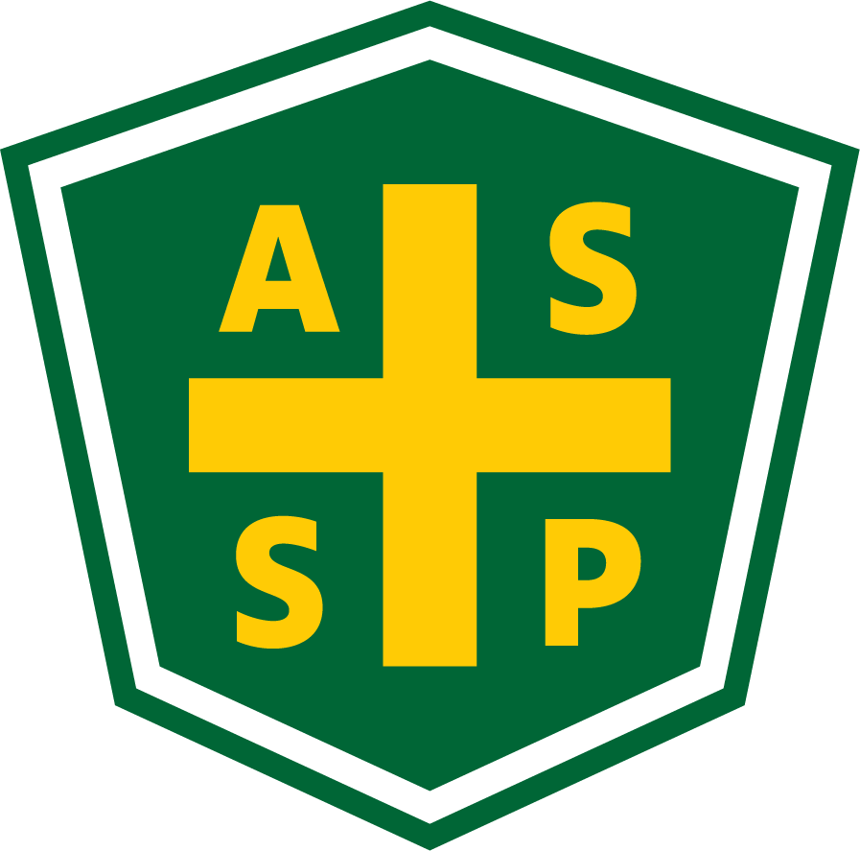
New Mexico Chapter – Albuquerque, New Mexico
Executive Board Committee Meeting Minutes
Tuesday, October 5, 2021
5:00 PM-6:00 PM
Zoom Meeting
Call In – (301)715-8592
Meeting ID: 825 6366 4488
Passcode: 416057

Attendance:
President – Bill White | AL | Quorum Present? | Y
President Elect – Tim Riley | TC | Membership | NA
Vice President – Tim Stirrup | AL | Foundation | NP
Treasurer – Gail Mattson | TC | Los Alamos Section | NP
Secretary – Jessica Bolduc | TC | Pecos Valley Section | NP
Delegate – Marc Evans | TC | Zia Section | NP
Delegate – Kelsey Forde | TC | Newsletter Editor - Andrea Heacock-Reyes | TC

AL = At Location TC = Teleconferenced NP = Not Present
Note: All motions should include exact wording and names of those who move and second.

Call to order: 17:12

Topic 1 | Meeting Minutes | Bill White
 | - Read and approved
Topic 2 | Treasurer’s Report | Gail Mattson
- Read and approved - 10/5/2021
- Report provided on 10/5/2021 attached on page 3
Topic 3 | Vice President Report | Tim Stirrup
- Recognize Mark Evans COVID -19 Leadership at October Technical Meeting
- Technical meeting - October
  - Rio Bravo Brewing Company - Barrel Room
    - Provide additional tip to server - ASSP $20 - Motion from Tim Stirrup, Second Bill White, Motion passed.
  - Kelsey Forde & Tim Stirrup - Parvati Consulting
  - October 13, 2021
  - Provide mileage reimbursement to Gail Mattson for Technical Meeting
- Technical Meeting - November
  - Copper Canyon
  - Sharron Jaramillo - SeedCrest
  - November 11, 2021
- Technical/Member Meeting - December
  - Membership appreciation event
  - FoodBank Donation - with NMASSP Match
  - Location - Zinc Wine Bar
  - December 7th (check availability)
Topic 4 | Unfinished Business
 | - Carol Walker - CEUs  - Kelsey will follow-up with Exhibit for attendance list  - Note the potential for issues with upcoming PDC and CEUs due to slow response in 2021.  - Science Fair  - Tim Riley - Commit?  - Contact info for Central Regional Fair  - ROC  - Held in Utah - Bill attended  - Region 2 - Virtual meeting for Tech meeting once for each chapter - “Super Duper Super Meeting”  - Leadership Conference  - October 21-22, 2021  - Virtual, no charge  - Newsletter  - Send messages incessantly until articles are provided. | Kelsey Forde  Bill White with Tim Stirrup and Tim Riley  Bill White  Bill White with Jessica Bolduc  Bill White with Andrea Heacock-Reyes
Topic 5 | New Business / Roundtable
 | - Delegate meeting  - By-law rolls discussion no consensus - no vote, proxy vote  - Invite Carol Walker to future Exec Meetings | Kelsey Forde  Marc Evans

Meeting Adjourned: 18:06

Next Executive Committee Meeting: November 2, 2021

Minutes respectfully submitted by Jessica Bolduc, Chapter Secretary, 10/6/2021.

Treasurer Report – Sept 30, 2021

9/30/2021 - update
(Outstanding Checks) | $0.00
SACU Checking | $12,433.89
SACU Savings | $5,125.35
SACU CD | $13,686.80
Total | $31,246.04

September Transactions:
9/08/21 - $204.00 USPS
9/30/21 + $125.00 Dues
No Checks On Hold

