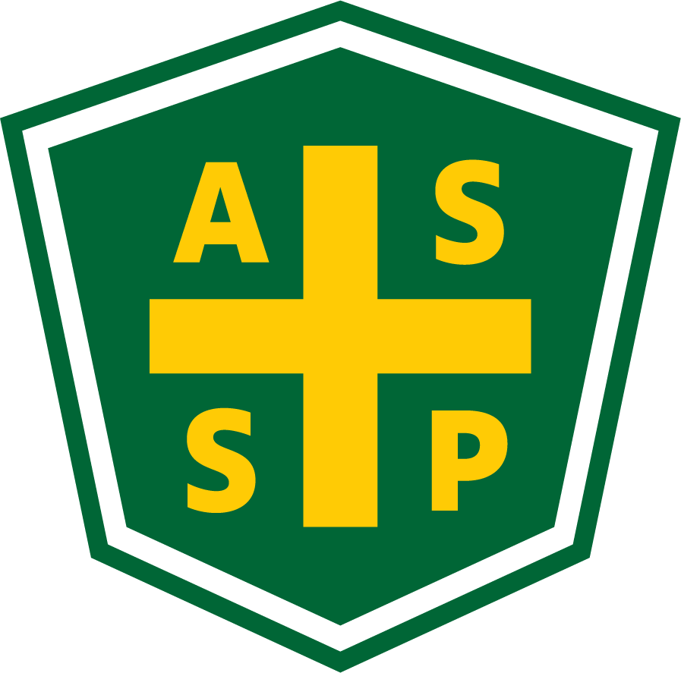
New Mexico Chapter – Albuquerque, New Mexico
Executive Board Committee Meeting Minutes
Tuesday, February 1, 2022
5:00 PM-6:00 PM
Zoom Meeting
Call In – (301)715-8592
Meeting ID: 857 1550 8311
Passcode: 928131

Attendance:
President – Bill White | TC | Quorum Present? | Y
President Elect – Tim Riley | TC | Membership | NA
Vice President – Tim Stirrup | TC | Foundation | NP
Treasurer – Gail Mattson | NP | Los Alamos Section | NP
Secretary – Jessica Bolduc | TC | Pecos Valley Section | NP
Delegate – Marc Evans | NP | Zia Section | NP
Delegate – Kelsey Forde | TC | Four Corners Chapter Visitor - Dashelle Ricord | TC
 |  | Newsletter Editor - Andrea Heacock-Reyes | TC

AL = At Location TC = Teleconferenced NP = Not Present
Note: All motions should include exact wording and names of those who moe and second.

Call to order: 17:03

Topic 1 | Meeting Minutes - 1/4/2022 | Bill White
- Read
- Approved with changes (Changes made by JTB at time of recommendation)
Topic 2 | Treasurer’s Report | Bill White
- Received 2/1//2022
- Read
- Discussion on CD earnings tabled for this month
- Roadrunner Food Bank match - LinkedIn post
Topic 3 | Vice President Report | Tim Stirrup
 | - None this month
Topic 4 | Unfinished Business
 | - Science Fair - Multiple halls for social distancing; judging online; safety inspection takes place in person. February 23rd to 26th (deadline Feb. 9 to register students)  - PDC - Hybrid event; Sandia Casino discussion; restrictions on hybrid event needs? Engage Exhibit for hybrid portion.  - Survey - gauge interest  - Check with Society on dates for Technical meetings  - February - Bill Johnson @ Rio Bravo Brewing  - March - Janet Kerley in Santa Fe  - April - Nordquist - Sandia Internal Audit  - Executive meeting online only until further notice.  - Newsletter - In progress  - Safety focus each month  - Credit Union email change - Jessica to remind Gail | Tim Riley  Tim Riley  Bill White  Bill White  Andrea Heacock-Reyes  Bill White
Topic 5 | New Business
 | - Sewer treatment plant - needs an audit by safety professional - email sent to membership  - Dashelle Ricord attending meeting - Four Corners Chapter new president looking for networking and Chapter guidance  - Recommendations?  - Working with Colorado Chapter and New Mexico Chapter to work together on meetings and events  - Super-meetings with Region II?  - Elections and COMT coming up in June  - Candidates and elections | Bill White  Dashelle Ricord  Bill White
Topic 6 | Roundtable
 | - Nothing this month.

Meeting Adjourned: 17:48

Next Executive Committee Meeting: March 1, 2022

Minutes respectfully submitted by Jessica Bolduc, Chapter Secretary, 3/1/2022.

