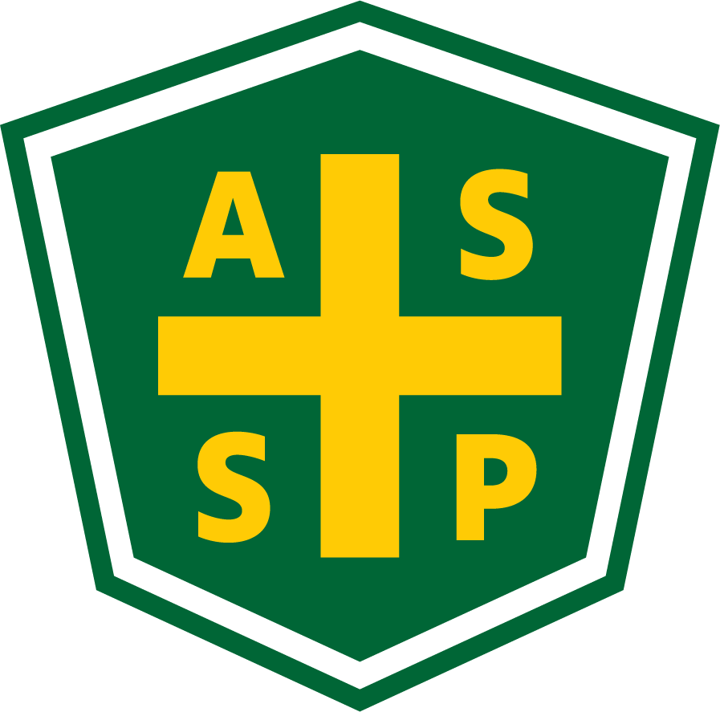
New Mexico Chapter – Albuquerque, New Mexico
Executive Board Committee Meeting Minutes
Tuesday, March 1, 2022
5:00 PM-6:00 PM
Zoom Meeting
Call In – (301)715-8592
Meeting ID: 857 1550 8311
Passcode: 928131

Attendance:
President – Bill White | TC | Quorum Present? | Y
President Elect – Tim Riley | TC | Membership | NA
Vice President – Tim Stirrup | TC | Foundation | NP
Treasurer – Gail Mattson | TC | Los Alamos Section | NP
Secretary – Jessica Bolduc | TC | Pecos Valley Section | NP
Delegate – Marc Evans |  | Zia Section | NP
Delegate – Kelsey Forde | TC | Newsletter Editor - Andrea Heacock-Reyes | NP

AL = At Location TC = Teleconferenced NP = Not Present
Note: All motions should include exact wording and names of those who move and second.

Call to order: 17:01

Topic 1 | Meeting Minutes - 2/1/2022 | Bill White
- Read
- Approved with changes (Changes made by JTB at time of recommendation)
Topic 2 | Treasurer’s Report | Gail Matteson
- Received 3/1/2022
- See the report at the end of these minutes; pages 3 & 4.
- Bill will follow-up with Marcl regarding the financial report, emails, and Technical meeting RSVPs.
- Discussion around other section leadership and fees.
Topic 3 | President-Elect Report | Tim Riley
- Science Fair email to local membership. Tim will reach out to Marc to coordinate email.
- PDC Discussion
  - Details to be determined by exec. committee.
    - In-person ✓
    - Sandia Casino ✓
    - May or June - Tim will check the schedule with Sandia.
    - 2 full days - identify tracks and speakers
    - Assume 100 people
Topic 4 | Vice President Report | Tim Stirrup
 | Nothing this month.
Topic 5 | Unfinished Business
 | - Newsletter - unknown status  - Sewer treatment plant - audit needs > Bill to Kelsey  - Thanks from Dashelle for sitting in on the February Exec. meeting  - Super Meeting - Region 2 – Still in the works  - Elections - Prospective officers  - Anyone identified for VP?  - Confirm Marc Evans continuing as delegate?  - Current roles continuing on?  - COMT - Due in June | Bill White  Bill White  Bill White  Bill White  Bill White  Bill White
Topic 6 | New Business
 | - Technical meeting speaker for May?  - Jessica to reach out to Andrew Forbes from RGAIHA about speaking. | Tim Stirrup
Topic 7 | Roundtable
 | - Nothing this month.

Meeting Adjourned: 17:57

Next Executive Committee Meeting: April 5, 2022

Minutes respectfully submitted by Jessica Bolduc, Chapter Secretary, April 4, 2022.

Please find attached the Treasurer's Report for February 2022.

2/28/2022 - update
(Outstanding Checks) | CK 1111 $304.00  CK 1112 $13.12
SACU Checking | $11,488.71
SACU Savings | $5,127.50
SACU CD | $13,830.17
Total | $30,446.38

February Transactions:
2/10/22 - $29.96 – Rio Bravo Brewing Company for Technical Meeting
2/12/22 - $13.12 – Kelsey Forde for UPS charges for shipping gift [still has not cleared]
2/28/22 + $85.00 - Net deposit from ASSP as have not yet received Feb 2022 financial report from ASSP

Notes:
- Per Email from Bill White the 1/28/22 $195.00 – Transfer to ASSP Des Plaines, IL was for his membership renewal
- Gail to follow-up on other options for investment of $s currently in SACU CD for better return but still accessibility to support future PDCs.

Other Actions:
- Will be coordinating with Janet Curley next week regarding joint meeting with NMSHMM on March 8, 2022 at SFCC Continuing Education & Contract Training Center in Santa Fe and purchase refreshments. Should we send out a reminder for this meeting?
- March 2022 Exec Mtg – motion to authorize me to spend up to $100.00 for refreshments for Match 8th event.
- Obtain updated ASSP membership information and correct contacts so can send 2021 dues checks to other NM chapters

Please let me know if you have any questions or comments. - Gail

Gail G. Mattson, PE, CHMM, PMP
mattsongail@gmail.com
+1 865-850-1386

